**Lab Report for EESM5060 LAB6**

Student Name: Min Tianhao

Student ID: 20917572

Student Name: HUANG Jiaxi

Student ID: 20878623

1. Exercise 2A

(without content in this exercise, the points for the other exercise will not be counted.)

A. Screenshot of behavioral simulation (covering entire Vivado window)

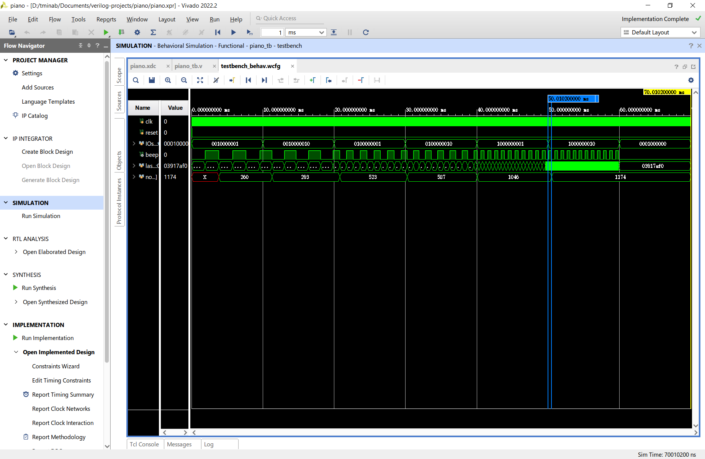

B. Screenshot of post-implementation timing simulation (covering entire   
Vivado window)

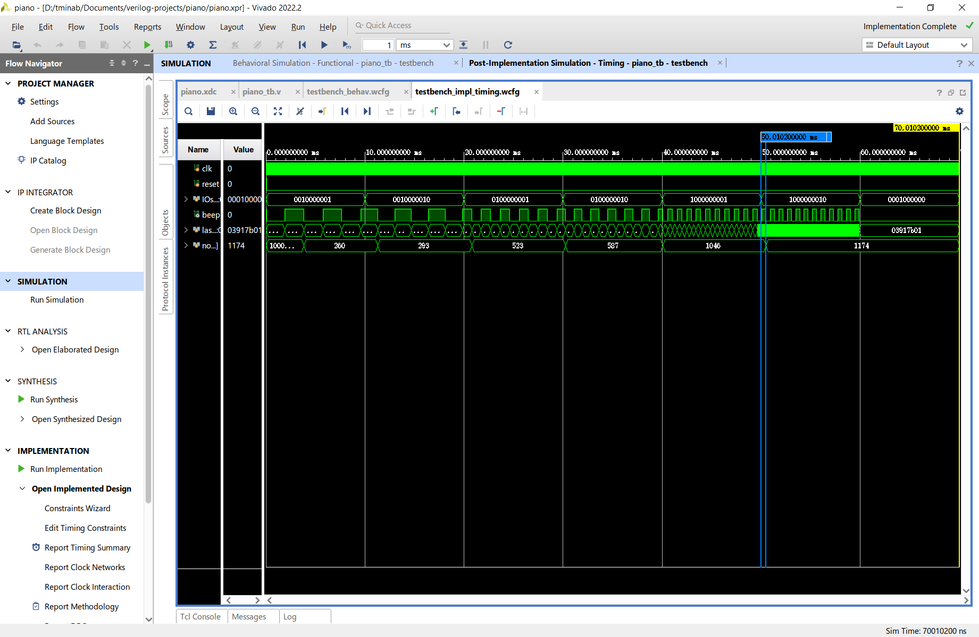

2. Exercise 2B

A. Modify the imported XDC file by changing the line “create_clock -period 10.000 -waveform {0.000 5.000} [get_ports clk_in]” to set a tighter clock period constraint. Change the clock period to 2 ns instead of 10 ns. (2 points)

A1) Did your design meet timing?

A: No, the design has a maximum total delay of 5.459 ns, which is larger than the 2 ns clock period.

A2) If your design meets the timing, please provide screenshots of post-implementation timing simulation.

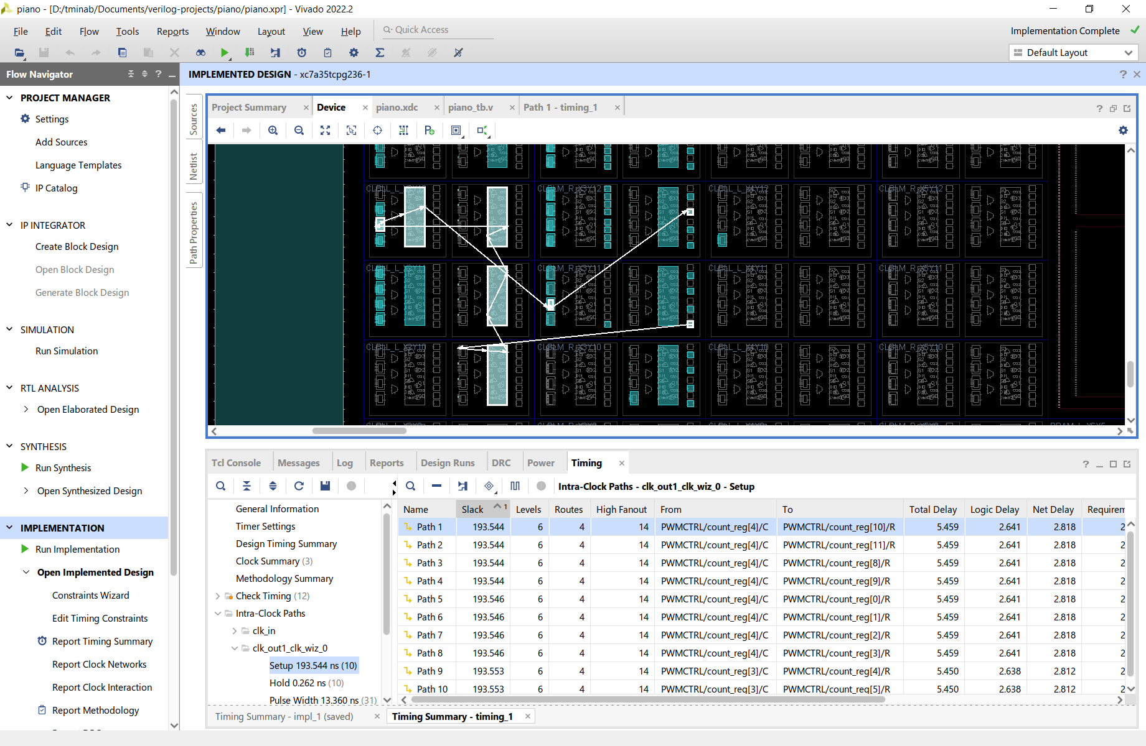

B. Modify the testbench.v file to provide different inputs to test your design. Repeat behavioral simulation and save the new testbench.v and a corresponding simulation screenshot in this report. (1 points)

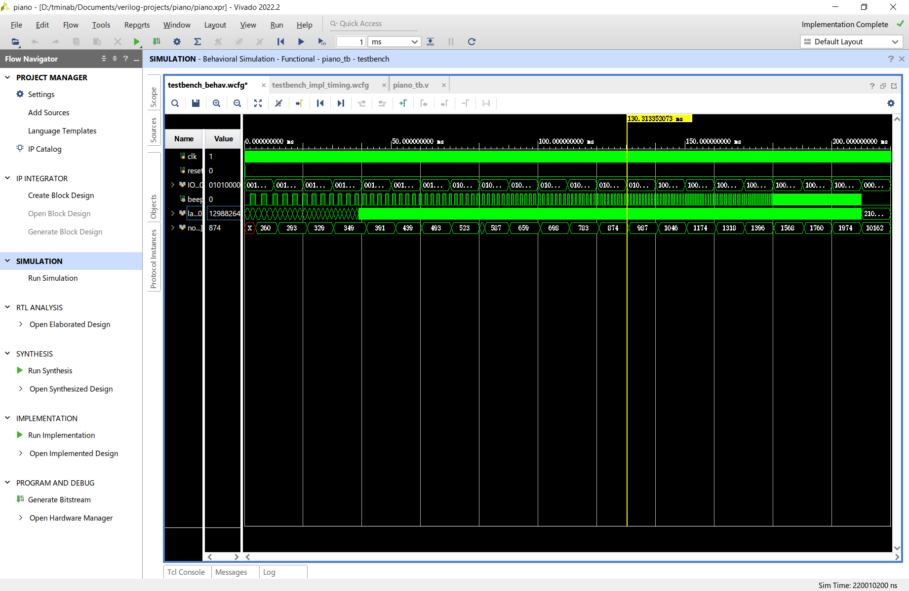

3. Exercise 2C

Attach your modified *keytofrequency.v* and the behavioral simulation screenshot in this report. (2 points)

**1. *keytofrequency.v*:**

|  |  |
| --- | --- |
| 1  2  3  4  5  6  7  8  9  10  11  12  13  14  15  16 | **`timescale** **1**ns / **1**ps  **module** keytofrequency(clk_5MHz, notecode, countStart);  **input** clk_5MHz;  **input** **wire**[**4**:**0**] notecode;  **output** **wire**[**13**:**0**] countStart;  blk_mem_gen_0 **BRAMROM**(  .clka(clk_5MHz),  .addra(notecode),  .douta(countStart),  .ena(**1**)  );  **endmodule** |

**2. screenshot:**

